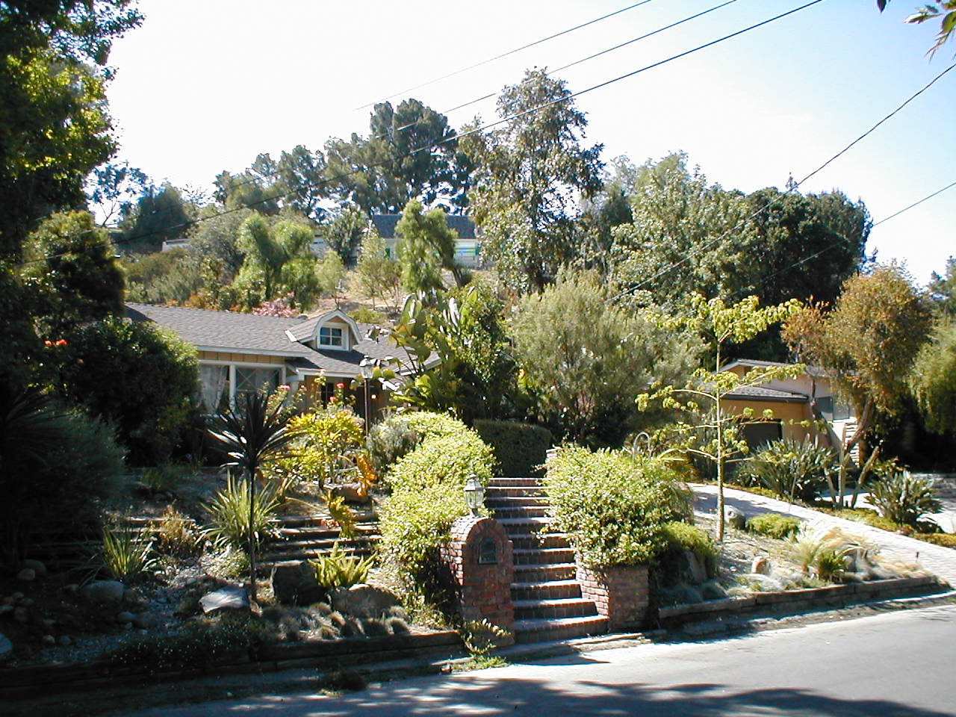

4873 Topeka Frontage

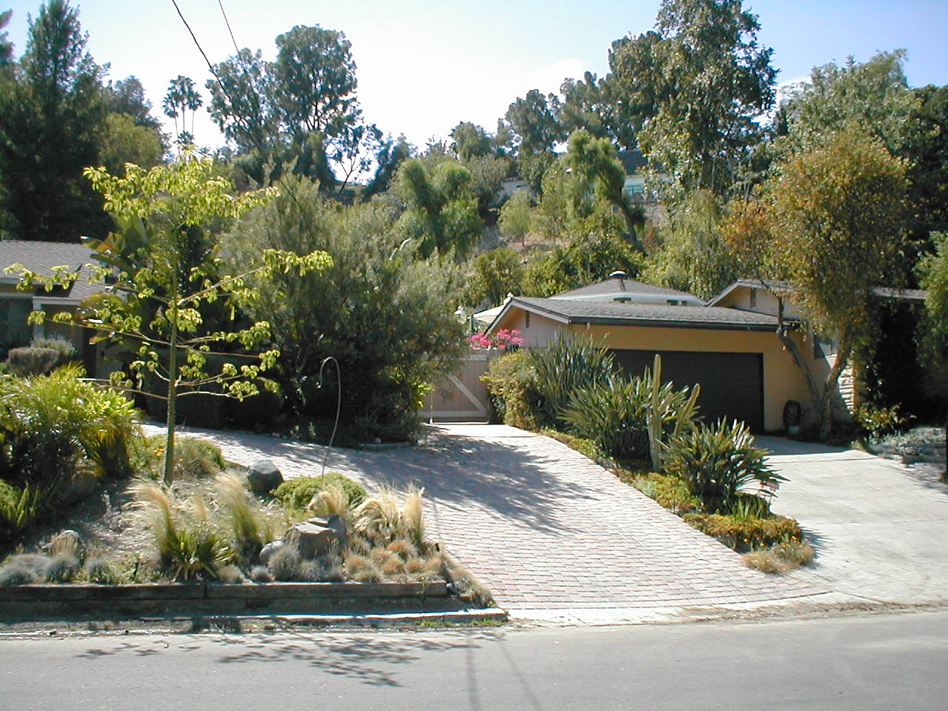\

4873 Topeka Driveway and Next Door Driveway