Tarzana NC Helps Secure Key Animal Services Funding
Jeffrey Mausner
May 25 2026

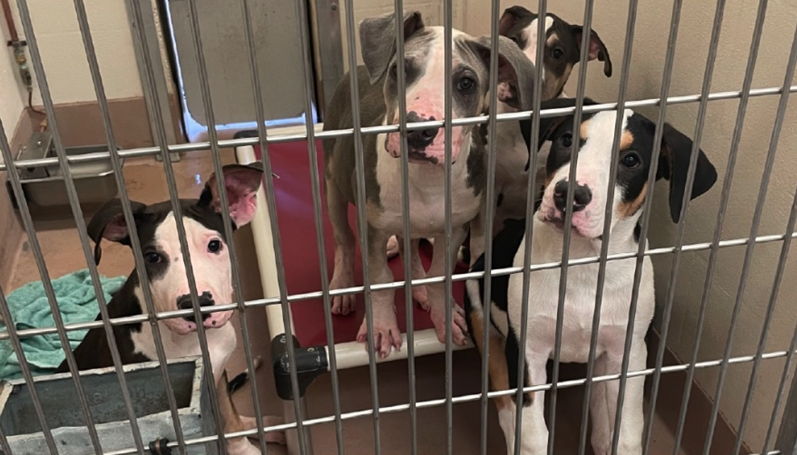

ANIMAL WATCH - The Los Angeles City Council Budget, Finance, and Innovation Committee has now voted on the 2026-27 budget for the L.A. Department of Animal Services (LAAS), and the results show that community advocacy can make a real difference, although significant unmet needs remain.
At a Special Meeting on May 4, the Tarzana Neighborhood Council (TNC) unanimously passed a Community Impact Statement (CIS) urging the City to stop starving the Animal Services budget and to fund the most urgent needs: spay/neuter, Dogs Playing for Life (DPFL), and animal food. That CIS, along with the Neighborhood Council Budget Advocates’ recommendations, helped shape the final budget proposals adopted by the Budget Committee.
For readers unfamiliar with the earlier coverage, Los Angeles Animal Services has been facing severe overcrowding of dogs and cats at the animal shelters, staffing shortages, increasing euthanasia, and inadequate funding for basic shelter operations. Volunteers, rescue groups, Neighborhood Councils, and animal welfare advocates have repeatedly warned that without additional funding, conditions for the animals, staff, and volunteers would continue to deteriorate.
An earlier CityWatch article explaining the crisis and the TNC CIS can be found here: Tarzana Neighborhood Council to City Hall: Stop Starving LA’s Animal Services Budget.
The Tarzana Neighborhood Council CIS itself is posted here: https://cityclerk.lacity.org/onlinedocs/2026/26-0600_cis_05-04-2026.pdf
The Budget Advocates Report is here: https://www.tarzananc.org/assets/documents/1/committee695ad62838751.pdf
The Budget and Finance Committee’s increases are posted here: https://www.tarzananc.org/assets/documents/1/meeting6a11268a6eda9.pdf
Councilmember Bob Blumenfield’s statement on the budget increases is here: https://www.tarzananc.org/assets/documents/1/meeting6a1126ab312b8.pdf
Below is a summary what the City Council Budget Committee approved, and what still needs to be done. These increases now move to the full City Council for final adoption before the June 1 budget deadline.
Full Funding for Dogs Playing for Life (DPFL)
The most significant victory is the approval of $1,534,000 for a full year of Dogs Playing for Life (DPFL). This program is essential to the physical and psychological well-being of shelter dogs. DPFL provides daily playgroups, enrichment, socialization, and behavior assessment for shelter dogs, reducing kennel stress, improving adoptability, and saving lives. Animal welfare professionals widely recognize enrichment and socialization as critical components of humane shelter operations. Without DPFL, dogs deteriorate quickly in overcrowded kennels. With it, they have a chance.
The Budget Committee’s approval ensures DPFL will continue through the 2026–27 fiscal year. The next challenge will be ensuring the contract is renewed for 2027–28 and beyond, with stable annual funding.
Spay/Neuter Funding Increased, But Still Not Enough
The Budget Committee approved an additional $1 million for spay/neuter vouchers, bringing the total to approximately $7 million. The additional $1 million will fund roughly 8,000 additional sterilizations, preventing many thousands of unwanted dogs and cats from entering our already overcrowded shelters.
But the Tarzana Neighborhood Council and the Budget Advocates recommended approximately $12 million ($5 million more), based on the scale of the crisis.
As explained in the earlier CityWatch articles, and in the CIS and Budget Advocates Report: “Failure to provide adequate funding for spay/neuter is penny wise and ‘pound’ foolish.”
In Los Angeles, that is not just a figure of speech; it is dog-pound foolish, the most expensive kind of foolish there is. Unsterilized animals lead to more animals entering shelters, more overcrowding, more disease, more suffering, more euthanasia, and higher costs for the City.
If the Department runs out of vouchers, as it has in past years, a supplemental budget request will be necessary. Spay/neuter remains the most humane and cost-effective tool we have to deal with the shelter crisis.
Medical Supplies: $340,000 Approved
The Budget Committee approved $340,000 for medical supplies. If additional funds are needed, the Department may need to draw from the Animal Welfare Trust Fund or submit a supplemental request. Given the medical needs of shelter animals, this line item will require close monitoring.
Animal Food: $200,000 Approved, Far Below What Is Needed
The Budget Committee approved $200,000 for animal food. The TNC CIS recommended $600,000. It is contemplated that the remaining $400,000 may need to come from the Animal Welfare Trust Fund, but food for shelter animals should be a core City budget responsibility, not dependent on charitable funds. If food runs out mid-year, a supplemental budget request will be necessary.
Why These Increases Matter
The earlier CityWatch article laid out the crisis clearly: https://www.citywatchla.com/animal-watch/32684-tarzana-neighborhood-council-to-city-hall-stop-starving-las-animal-services-budget
Los Angeles shelters are severely overcrowded. Healthy adoptable dogs are being killed for lack of space. Animals are deteriorating physically and emotionally. Staff, volunteers, and rescue organizations are overwhelmed.
The Tarzana Neighborhood Council CIS and Budget Advocates Report both emphasized:
- Spay/neuter reduces intake, the root cause of overcrowding.
- DPFL reduces suffering and increases live outcomes for dogs already in the shelters.
- Food and medical supplies are basic necessities, not optional extras.
These are not luxuries. They are the minimum required for a humane and functional shelter system.
Community Advocacy Made a Difference
Thank you to City Councilmember Bob Blumenfield, Vice Chair of the Budget Committee, who pushed for these increases, and to his staff including the Legislative Director, Jeff Jacobberger, who thanked the Tarzana Neighborhood Council for submitting the CIS. Thank you to the others who advocated for these increases. This outcome shows that when Neighborhood Councils, the Budget Advocates, volunteers, and community members speak up together, the City listens. But it also shows that the fight is not over.
What Comes Next
To ensure progress continues:
- The DPFL contract must be renewed for 2027–28 and beyond.
- Spay/neuter funding must be increased to the level needed to significantly reduce shelter intake.
- Food and medical supplies must be funded as core City services, not left to charitable funds.
- Supplemental budget requests must be submitted promptly if funds run out mid-year.
The animals in our shelters do not have a direct vote in City elections. But they have us. And as long as we continue to stand up for them, we can make sure the City does too.

