Budget Committee Motions for Board Meeting
February 24, 2015

Item 8. "Resolved that based on the recommendation of the TNC Budget Committee the TNC approve $200 for expenses for the VANC 12th Anniversary Mixer, to be classified as Outreach, Events and come from Unallocated." We have supported this event in the past by contributing $200 toward some expenses. The suggestion is to provide $200 this year for this event. Earlier this year we supported another VANC event also for $200.
**************************************************************************************************
From: jbbarad@roadrunner.com [mailto:jbbarad@roadrunner.com]
Sent: Tuesday, February 10, 2015 8:24 PM
To: jbbarad@roadrunner.com
Subject: Valley Alliance of NCs meeting, Thursday, February 12

Dear Valley Alliance of Neighborhood Council representatives and friends,
"......{subject deleted}

Be sure to mark your calendar for our 12th Anniversary Mixer at CBS Studios on March 12. We are still seeking Sponsors (see attached information on
sponsorship) and we will be awarding our "Best of.." Awards for outstanding neighborhood council activities (see attachment on submitting nominations).

Our Mixer is always a good event for neighborhood council board members and committee chairs to mingle and talk informally about council issues and events.
In addition, we have drawings for fun door prizes. WE NEED DOOR PRIZES so if you have any access to restaurants, movies, goodies or other businesses that might want to donate door prizes, please don't hesitate to approach them. We will give Door Prize donors credit at the Mixer.

I look forward to seeing you this Thursday and at our Mixer in March.

Best,
Jill Banks Barad, Founder and Chair

Valley Alliance of Neighborhood Councils

It’s Not Too Late!

Sponsorship of VANC 12th Anniversary Mixer
March 12, 2015, at CBS Studios, Studio City
5:30-9:30 p.m.

Come mingle with elected City officials, heads of City departments and almost 200 of your Neighborhood Council colleagues. There will be “Best of…”awards for extraordinary efforts by Neighborhood Councils across the Valley.

* For over 12 years, VANC has been devoted to providing educational and outreach opportunities for all 34 neighborhood councils in the Valley. In addition to monthly meetings that address issues of regional and City interest, VANC regularly hosts candidate debates and planning forums.

Grayce Liu, General Manager of DONE, is very supportive of our Alliance and our events. VANC has worked with DONE funding to provide an easy means for individual neighborhood councils to contribute to our events.

Refreshments will be provided, as well as a cash bar at the Mixer. There is no cost to your Board members and Committee members to attend. You will be receiving a flyer. Programs will be available the night of the event.

To SPONSOR:
Please contact VicViereck @sbcglobal.net or (818) 985-9174.
Vic will give you instructions for your council’s contribution as a Sponsor. Your NC will be listed on the flyer and the Program, and your council will be thanked publicly. Contributions of any amount are appreciated.

*************************************************************************************************
Item 9 . "Resolved that based on the recommendation of the TNC Budget Committee the TNC approve the request from Tarzana Elementary School for a NPG for $4,000 to assist with the cost of their physical education program to come from Unallocated." Last year we approved a $4,000 grant for this program.
**************************************************************************************************
See details of NPG on the next page.

Item 10. "Resolved that based on the recommendation of the TNC Budget Committee the TNC approve a request from the Community Relations section of the West Valley LAPD to support the Baker to Las Vegas Run event by purchasing 50 jackets for the participants and their support group, which will include the TNC logo for not more than $1,500, to be classified as Outreach, Advertising and to come from Unallocated." This is a big event for law enforcement with police department from all over the US participating.
**************************************************************************************************
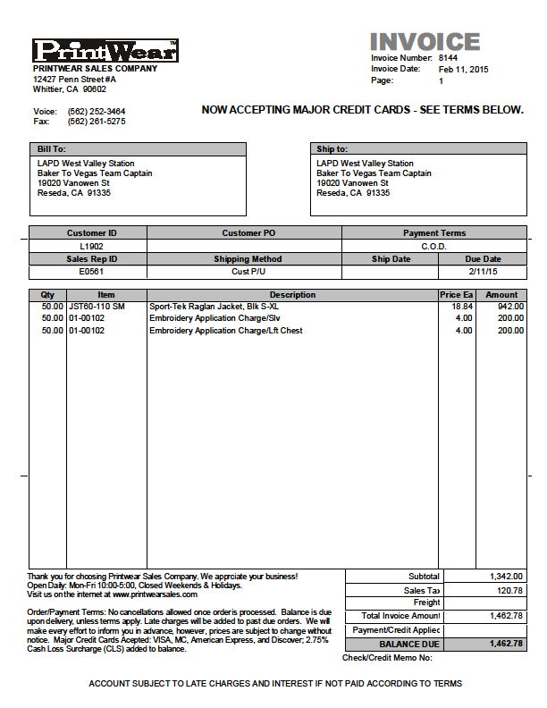

Item 11. "Resolved that based on the recommendation of the TNC Budget Committee the TNC approve a NPG to the West Valley-Warner Center Chamber of Commerce Community Benefit Foundation for $1,500. These funds were previously budgeted." In connection with the 2015 Earth Day Celebration, the TNC will be giving each of the six participating schools $250 as a grant for participating. Rather than creating six separate NPG's we are processing one through the West Valley Warner Center Chamber of Commerce Community Benefit Foundation for $1,500, and they will distribute the money directly to each school.
**************************************************************************************************
The copy of the NPG is attached.
**************************************************************************************************

Item 12. "Resolved that based on the recommendation of the TNC Budget Committee the TNC approve an increase in the cost of the Tarzana Welcome sign to NTE $1,700 from $600, an increase of $1,100, to be classified as Outreach, Advertising, Tarzana Welcome Sign to come from Unallocated." The Tarzana NC previously approved $600 for the replacement of this sign. Upon further review and requesting a firm quote it was determined that the total cost is $1,664.04. This includes the cost of refurbishing the sign structure. If TPOA and the Chamber want to continue to use the bottom portion of the sign, they will have to pay a pro-rata portion of the total cost, if not the TNC will pay the total cost and the sign will be limited to them. The quote is shown below. **************************************************************************************************

