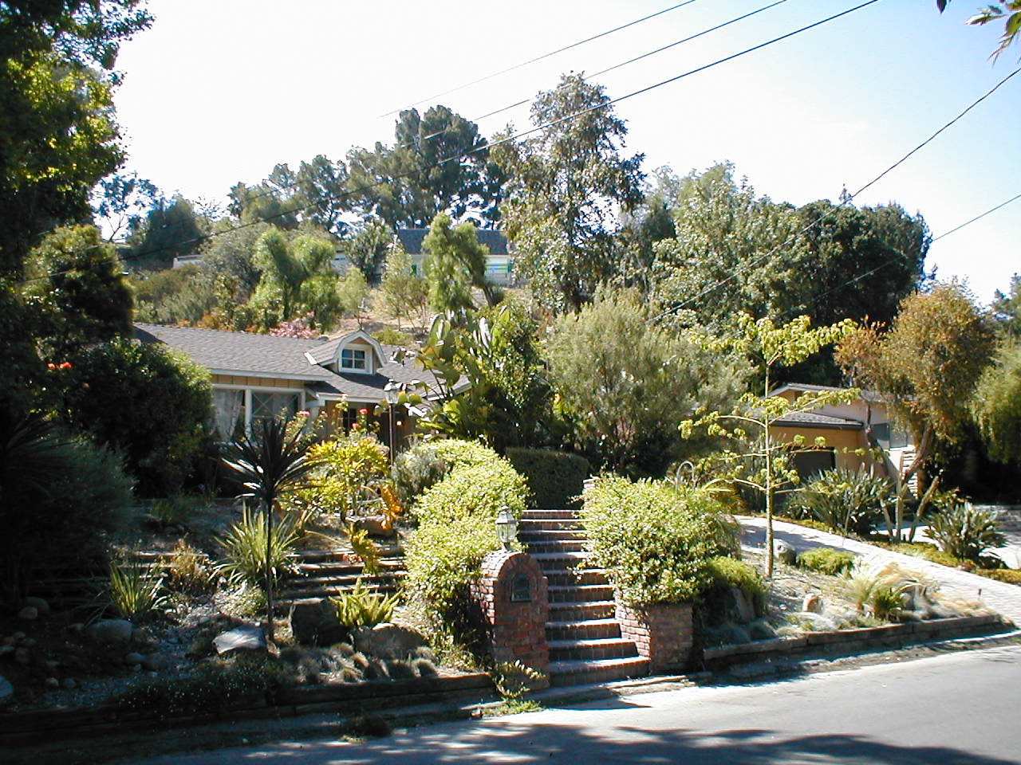
4873 Topeka Frontage
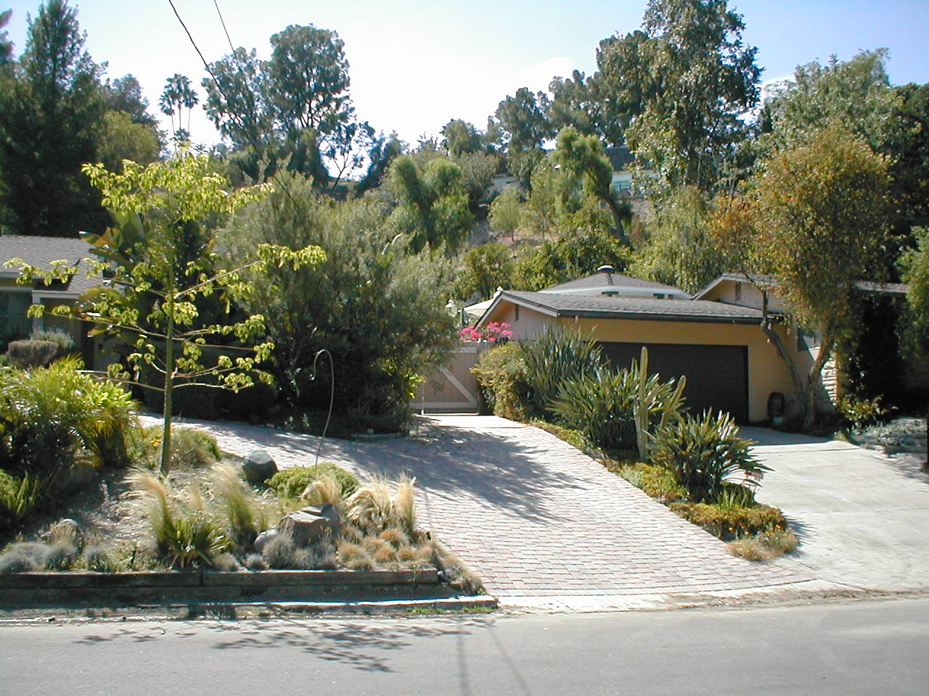\
4873 Topeka Driveway and Next Door Driveway

