Info for Budget Committee Meeting
March 16, 2016

Item 6. The Board previously approved $1,500 to give as a participation allowance for each school that participates in the Earth Day Poster Contest. In order to facilitate the funding of this money a NPG is being given to the WH-Tarzana Community Benefit Foundation, a non-profit, that will give $250 to each of the six schools that are participating. If not we and DONE would have to process 6 separate grant requests. A copy of the grant request is attached.
**************************************************************************************************
Item 7. Tarzana Elementary School has requested a NPG to support their Accelerated Reader Software Program for the next school year, 2016-17, in the amount of $4,116.50. Previously this program was funded by Title 1 Categorical funds, but because of cutbacks, funds will not be available for this program. In prior years our NC has helped fund their Physical Education program in similar amounts. Tarzana Elementary School provides us with meeting space for our Board meetings and some committee meetings at no charge to us although they are entitled to charge. A copy of the grant request is attached. **************************************************************************************************
Item 8. The Southern California Preparedness Foundation is running their 9th Annual disaster fair on October 1, 2016 at Fire Station 87 in Granada Hills. This events regularly attracts over 2,000 people. Other NC's are participating. They are requesting a NPG for $850. For this we will receive a 10ft x 10ft booth and have our name in all the promotional material. At the beginning of this fiscal year we gave $250 for the event that was held in October 2015. A copy of the grant request is attached.
**************************************************************************************************
Item 9. West Valley LAPD Community Relations previously requested a NPG for $750 to support their participation in the Baker2Vegas relay race. Although it was approved by the NC, DONE felt that it was not a proper grant and would not authorize its disbursement. We have now been requested to purchase T-shirts for the participants and team members that will have the Tarzana NC name and logo on them. The cost for the shirts is $872.00. This expenditure will be classified as Outreach, Advertising.
**************************************************************************************************
(Jeff Olshane) Advanced Wholesale Embroidery  16127 Covello St.  Van Nuys 91406  (818) 779-1033 | INVOICE
Invoice #0001
Date: March 2, 2016

To:  Tarzana Neighborhood Council  19130 Ventura Blvd, Tarzana, CA 91356  Phone:(818) 345-1966 | For:  LAPD West Valley Baker to Vegas Running Team

DESCRIPTION | Amount | Price | AMOUNT
Tech Running Shirts | 6-Small  6- Medium  11- Large  3-XL | @ $19.00 each | $494.00
Tee Shirts | 7-Small  8- Medium  14- Large  12- XL  1- XXL | @ $9.00 each | $378.00
 |  | TOTAL | $872.00
Make all checks payable to (Jeff Olshane)
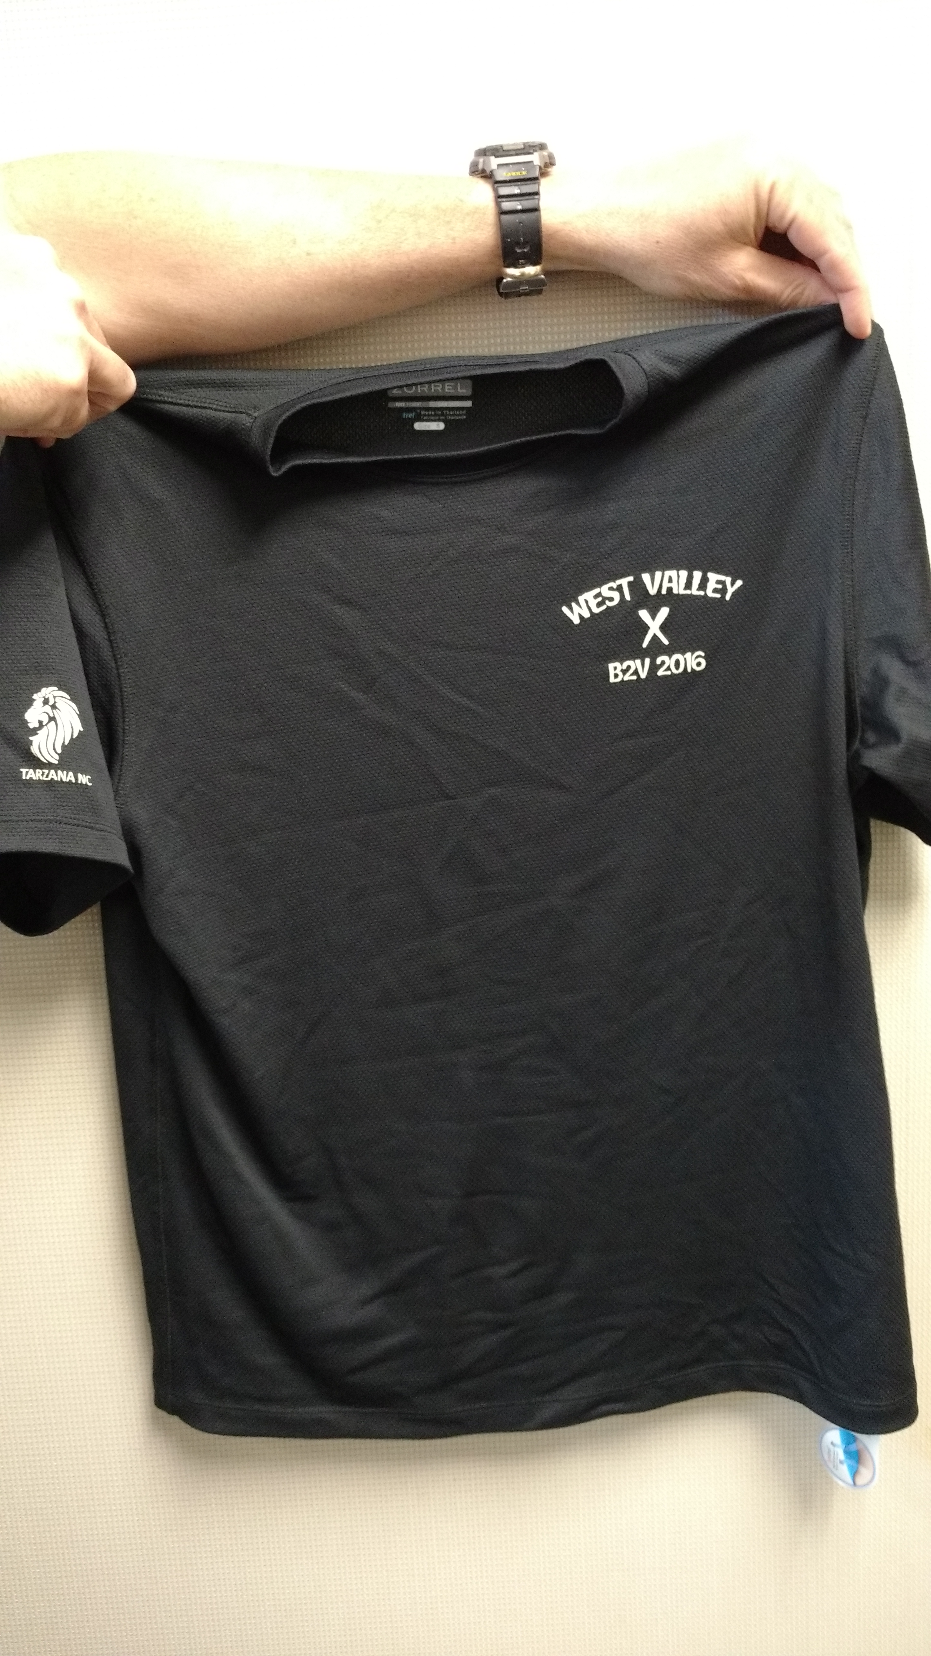

Item 10. The Tarzana Recreation Center runs a summer camp for local children. For the past several years we have purchased T-shirts for the camp participants and staff. These T-shirts contain the Tarzana NC name and logo on the back along with the camp information on the front. The cost for 315 shirts is $2,443.78. The Tarzana Recreation Center provides our NC with office space and meeting rooms as well as a location to hold various events, including Earth Day, at no charge to our NC. A price quote and sample of the T-shirts is below.
**************************************************************************************************
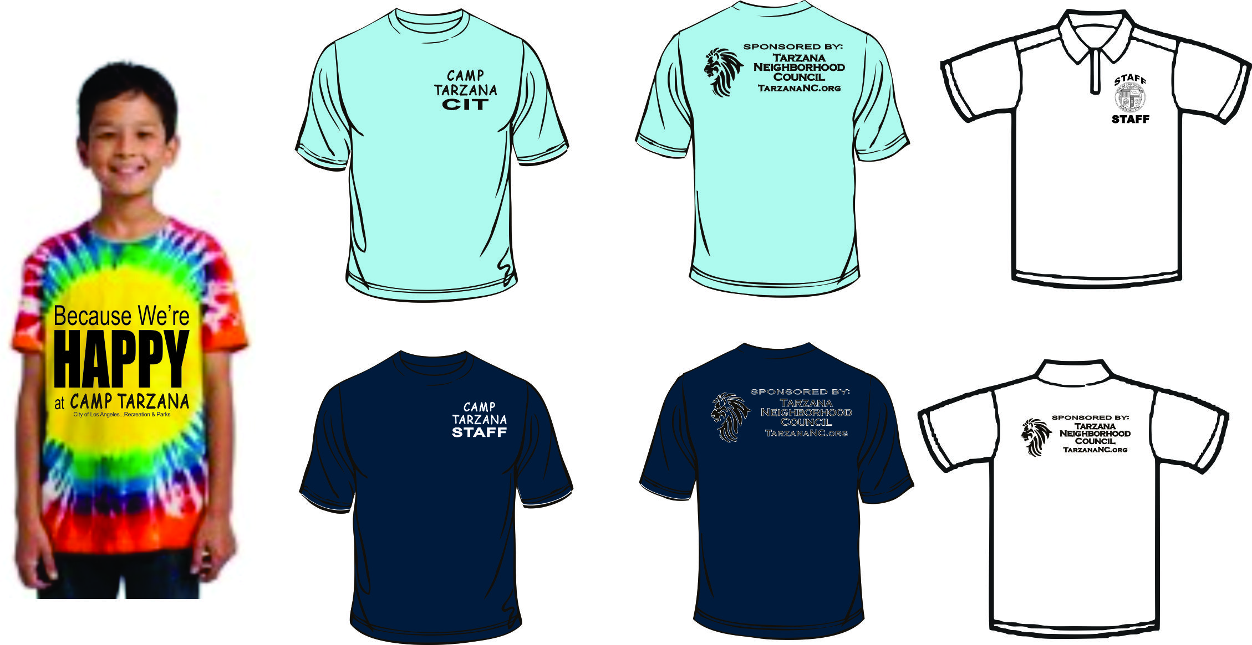
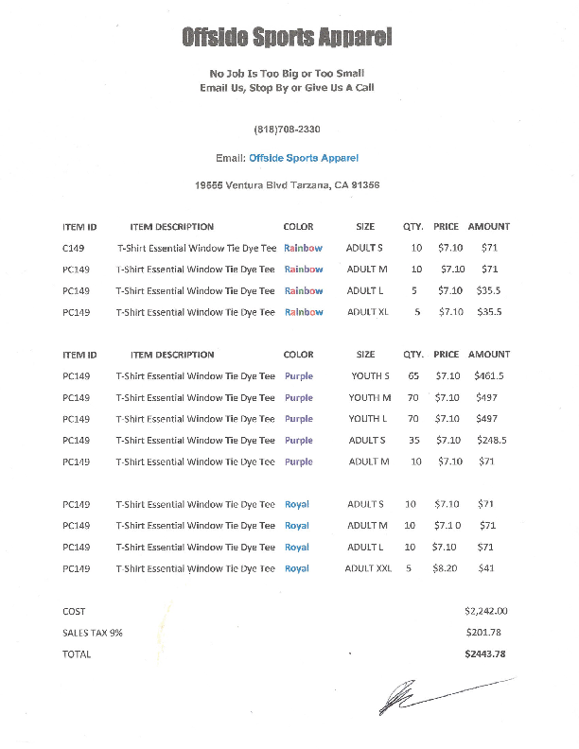

Item 11. We received a request from the chair of the Outreach Committee to increase the budget from $200 to $260 for Outreach, Events, Earth Day, Supplies-On Site (this covers purchases for the day of the event expenses such as tablecloths, paper towels and water). Last year we spent $67. The reason is that they would like to purchase 1,000 bottles of water in anticipation of hot weather on the day of the event. A request to support the calculation of this number has not been received.
**************************************************************************************************
Item 12. A request was received from the Outreach Committee to purchase T-shirts for the volunteers (both Board members and other) for the Earth Day Event. The cost for 36 T-shirts is $305.20. The shirts will have the Earth Day logo on the front and the TNC logo and the word "Volunteer" on the back. This money is in addition to the funds previously budgeted for the event.
**************************************************************************************************
Offside Sports Apparel
No Job Is Too Big or Too Small
Email Us, Stop By or Give Us A Call
(818)708-2330
Email: Offside Sports Apparel
19555 Ventura Blvd Tarzana, CA 91356

ITEM ID ITEM DESCRIPTION COLOR QTY. SIZE – M –L -XL- XXL PRICE AMOUNT
880 Women’s T-Shirt City Green 12 2 4 3 3 $7.00 $84.00
980 Men’s T-Shirt City Green 24 6 10 8 $6.50 $156.00
T-shirt
Front: Earth-Day
2016
Logo (Earth Day logo) $20.00
Back: Tarzana Neighborhood Council
Logo (TNC logo)
Volunteers $20.00
COST $280.00
SALES TAX 9% $25.20
TOTAL $305.20

