Info for Budget Committee Meeting
May 19, 2015

Item 6. Reversal of monies previously budgeted but no longer needed to be expended during the current fiscal year.
**************************************************************************************************
Details are attached in the schedule Estimated Expenses FY 2014-15. The column that the reversals are identified in is the 3nd from the right "Potential Reversals as of May 19, 2015". The total amount is $8,055.83 which is the total on the line "900 Unallocated", the 3rd line from the bottom.
**************************************************************************************************
Item 7. The Tarzana Recreation Center has asked us to purchase T-Shirts for their 2015 Summer Camp. They are requesting 305 T-Shirts. Each of these shirts will have the TNC logo on the back and Rec Center info on the front. We previously purchased Shirt for the 2014 Summer Camp. **************************************************************************************************
Price quote from World's greatest Promotional Stuff follows:

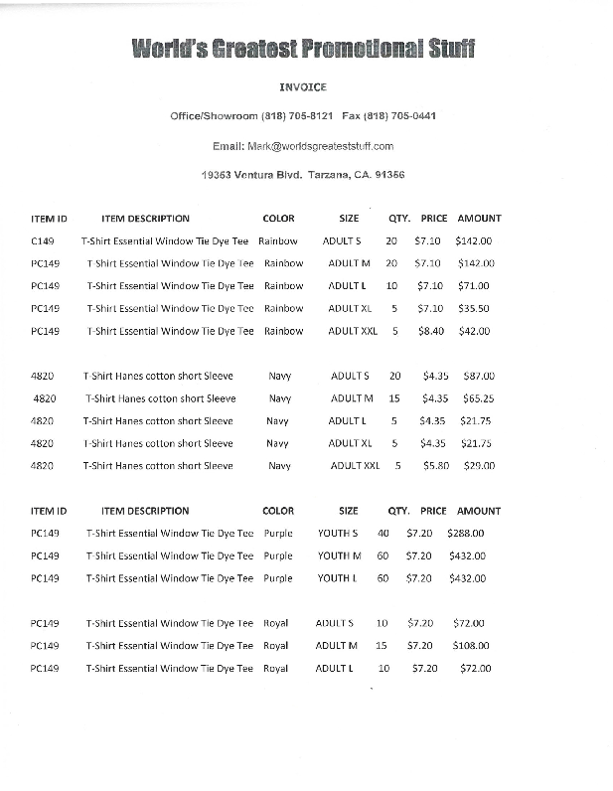

******************************************

**********************************************
************************************************************************************************** Item 8. The Outreach Committee wants to purchase 1,000 grocery tote bags with the TNC logo for distribution to the community at various events to promote the TNC and its web site and phone number. In addition, they want to purchase a table cover with the TNC name/logo to be used to cover our table when it is used at events. The cost of the table cover is $139 + tax. The total cost of the tote bags and cover is $1,661.16. The request is to authorize the purchase for the above items at NTE $1,675 from World's Greatest Promotional Stuff. This requires increasing the total budget for Outreach, Advertising, Promo Items by $710 from Unallocated. A price quote from World's Greatest Promotional Stuff is shown below.

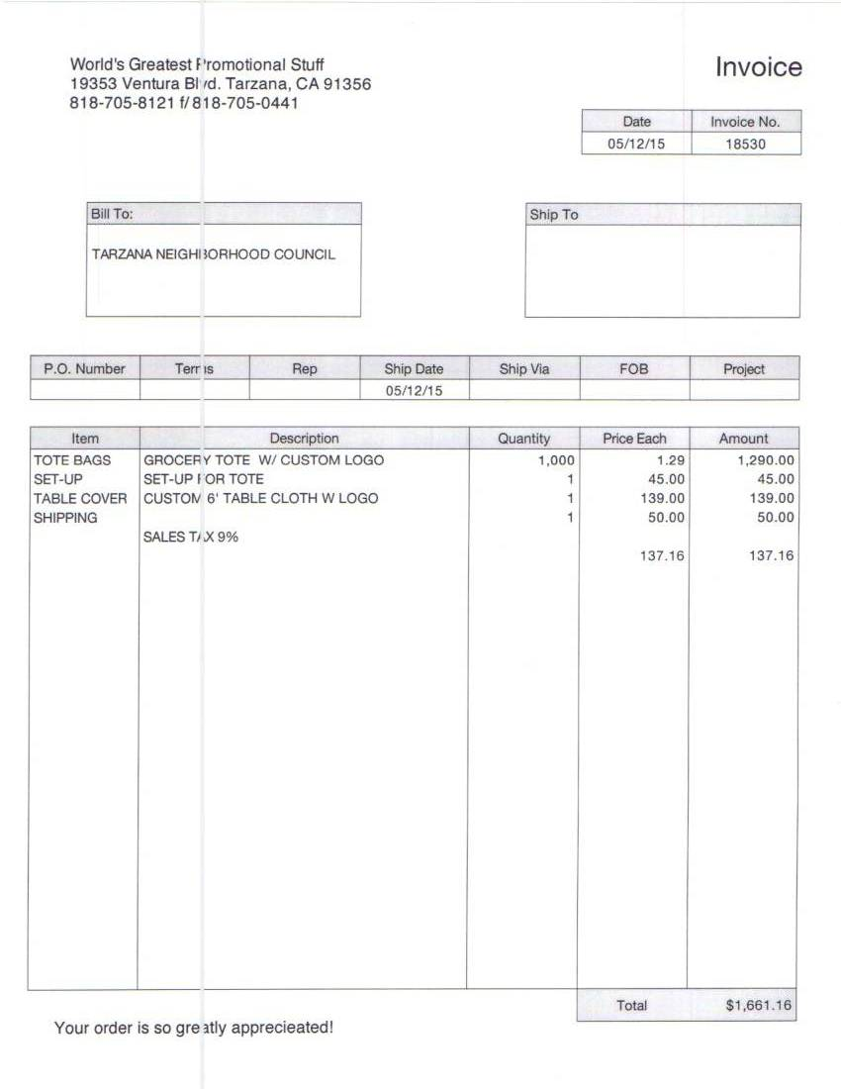

Item 9. The Treasurer would like to buy the latest version of QuickBooks Pro-2015. The current version being used QuickBooks Pro-2012 is no longer being supported by Intuit with upgrades. QuickBooks is being used to track all financial and budget transactions and prepare monthly financial statements. The cost, including sales tax, of the current version is approximately $225 (from Office Depot or a similar vendor). This requires increasing the budget for Operations, General, Budget by $148. The Funds will come from Unallocated.
*************************************************************************************************
Item 10. The cost to purchase labels for the Earth Day Event exceeded its budget of $150 by $2.08. As a result we have to increase the budget for Outreach, Events, Earth Day, Labels by $2.08. The funds will come from Unallocated.
**************************************************************************************************
Item 11. The West Valley LAPD Community Relations Office has requested that the TNC purchase several items that would assist the WVLAPD to perform their services better to the Tarzana community. Shown below are the details of the request. The total cost is NTE $3,500 to be classified as Community Improvement Projects and the funds will come from Unallocated.
**************************************************************************************************
Sergeant Larry Martinez
West Valley Community Police Station
19020 Vanowen Street
Reseda, Ca. 91335
Telephone: 818-374-7611
31179 @lapd.lacity.org
Date: May 13, 2015
2015 West Valley Police Wish List Items
Tarzana Neighborhood Council,

I hope all is well with everyone. Thank you for the continued support the Tarzana Neighborhood Council gives to the West Valley Police Station throughout the year. We have compiled a list of items that would enable us to do our jobs more efficiently. Thank you again and we look forward to working with everyone in the future.
Sergeant Larry Martinez #31179
Wish List Items
(1) Cordless Leaf Blower $152.21
(1) Antenna for the Command Post Vehicle $164.25
(10) Shotgun Flashlights $1,533
(1) 50” HDTV $438
(1) Wall Mount for TV $65.70
(2) EZ UP Canopies $523.41
(1) Epson Outdoor Projector $416

TOTAL: $3,292. 57

LAPD West Valley Area Funding Request

Cordless Leaf Blower
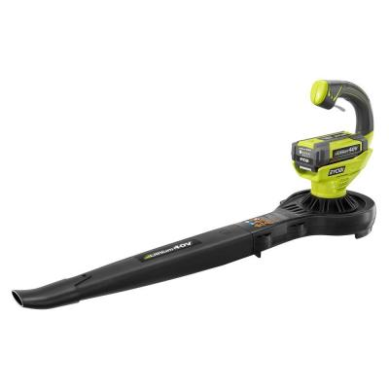
HOME DEPOT
Web Page: http://www.homedepot.com/p/Ryobi-150-mph-150-CFM-Lithium-Ion-Cordless-40-Volt-Blower-Sweeper-RY40410A/204322580
Ryobi
Model # RY40410A
Internet # 204322580
150 mph 150 CFM Lithium-Ion Cordless 40-Volt Blower/Sweeper
$139 + $13.21 Tax = $152.21
Ryobi takes Cordless to the next level with the 40-Volt Lithium-ion Blower. With a 40-Volt battery pack, this blower delivers longer runtime, fade-free power and quick charging.

West Valley is requesting a cordless leaf blower to clean around the station and parking structures.

MOHU Sky TV Attic/Outdoor Antenna, 60 Mile Range
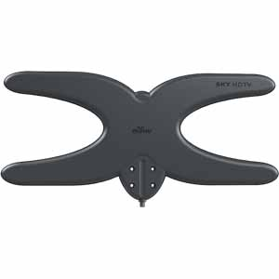
Frys.com #8003544
Manufacturer: GREENWAVE SCIENFTIC
UPC #854449004125
Model #MH-110585

FRYS.COM http://www.frys.com/product/8003544?site=sr:SEARCH:MAIN_RSLT_PG

$149.99 + $14.25 tax = $164.25

The Sky HDTV Attic / Outdoor Antenna is the newest addition to the Mohu family and offers a completely new take on the traditional rooftop or attic mounted antenna. Weighing in at only 3 pounds, the Sky Attic / Outdoor Antenna is a powerful, amplified antenna solution that was developed from research for the United States military.

West Valley is requesting this antenna to be used in our Mobile Command Post. The Command Post is used for all critical incidents.

Shotgun Flashlights

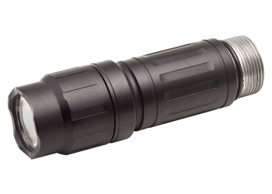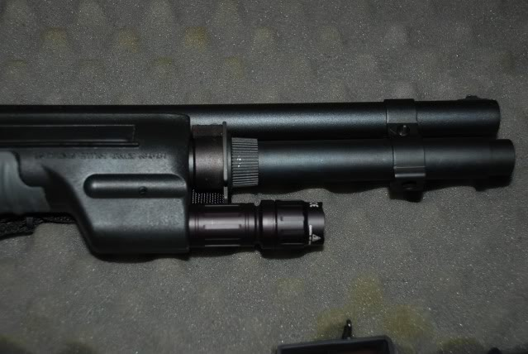

Surefire Company
Item# LED / LM2-A, 6V Lamp Assembly
Conversion for Fore End Weapon Lights- 2-Battery System
Request for 10 conversion kits

10 x $140 + $133 =$1,533

West Valley Area requests that we add or replace 10 flashlights that can be mounted on the shotguns. The flashlights allow our officers to tactically search areas that need illumination without having to hold a handheld flashlight while holding the shotgun.

50” HDTV – Black



Insignia™ - 50" Class (49.5" Diag.)

LED -1080p

Model: NS-50D420NA16

SKU: 1214006

Best Buy Web Page:
http://www.bestbuy.com/site/insignia-50-class-49-5-diag--led-1080p-hdtv-black/1214006.p?id=1219479932886&skuId=1214006

$400 + 38.00 Tax = $438

This TV would be for the front lobby of West Valley Station for the community watch while they are waiting.

Insignia™ - Fixed TV Wall Mount for Most 40" - 70" Flat-Panel TVs – Black

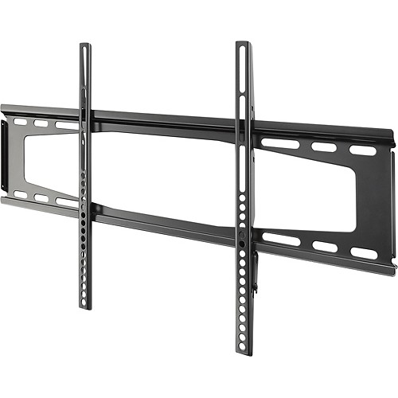
Model: NS-TVMFP23

SKU: 5148005

Best Buy web page: http://www.bestbuy.com/site/insignia-fixed-tv-wall-mount-for-most-40-70-flat-panel-tvs-black/5148005.p?id=1219112769002&skuId=5148005
$60.00 + $5.70 tax = $65.70

10x10 Canopies
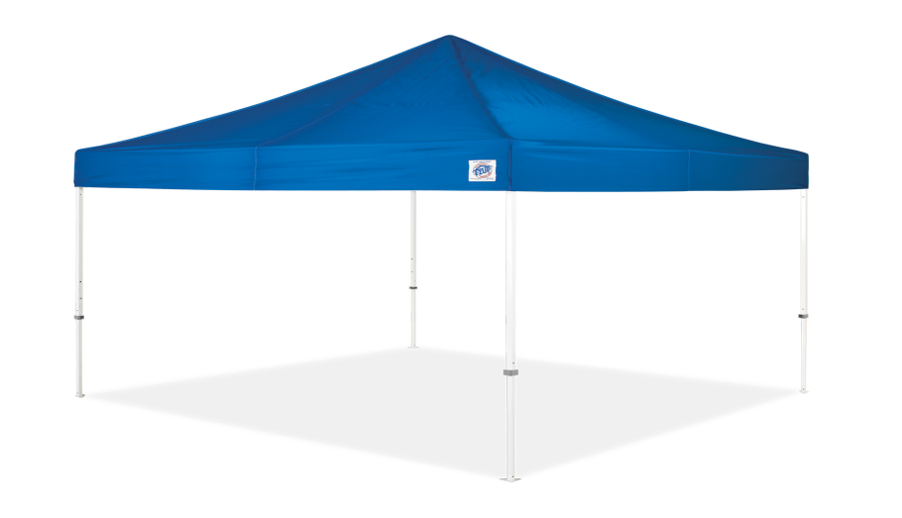

Vantage™ 10′ x 10′
E-Z UP® Vantage™ Instant Shelter® – Increase your visibility. Standing out at any events, street fairs or swap meets is easier than ever.
E-Z UP web page: http://www.ezupdirect.com/product/vantage-10-x-10/

We are requesting two (2) heavy duty canopies to be used by West Valley Division throughout the year.
2 x $239.00 = $478 + $45.41 tax = $523.41 Total

Epson PowerLite Home Cinema 600 Home Theatre Projector - Portable Projector

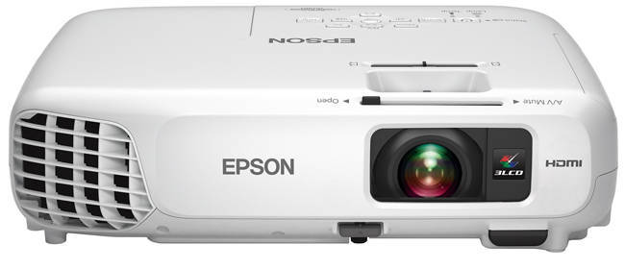

Discover how easy home theater can be with the Home Cinema 600 projector. Enjoy big-screen entertainment for the whole family, from movie nights to outdoor matinees - even life-size videogames. Delivering up to 3x ... Full Description

Dell web page: http://accessories.us.dell.com/sna/productdetail.aspx?c=us&l=en&cs=19&sku=A8248242&baynote_bnrank=0&baynote_irrank=0&~ck=baynoteSearch
$379.99 + $36.01 tax = $416.00

We are requesting this projector to use during community events.

**************************************************************************************************

Item 12. In the past years the NC's have been requested to and have help fund the annual Congress of Neighborhoods and to a lesser degree the Budget Advocates. In the past the City Council authorized DONE to maintain a special funding account that could total no more than $100,000 for the combined purposes. During the most current fiscal year the City Council has separated this account into two separate accounts and each can be funded up to a maximum of $100,000. The funding may come from any monies the NC's have not spent during their fiscal year and these monies are "rolled over" for the next fiscal year programs. This motion authorizes that any monies left over from this fiscal year, up to $6,000, can be earmarked for these events/programs in the ratio of 2/3 (up to $4,000) for the Congress and 1/3 (up to $2,000) for the Budget Advocates. Last year the TNC authorized up to $3,000 for the Congress, but only $1,000 was used/taken since the total account exceeded the authorized $100,000.
**************************************************************************************************
Item 13. This is the first request for funding for the next fiscal year (July 1, 2015-June 30, 2016). If a budget for an expenditure (an item) is not in place by July 1, 2015, not payments can be made for that expenditure. This is the first round of that budgeting. This budget can and will be amended during the year as situations and circumstances change. For administrative expenses (generally Operations and recurring Outreach) we must have a specific/detailed budget. For specific events and projects a "holding/estimate amount" will suffice since the Board must ultimately approve the details of any expenditures. In addition the Board must approve all expenditures over $50 unless they have been preauthorized.

The initial proposal, which is detailed on the attached schedule "BUDGET FY 2015-16", includes an estimated $6,000 for election related expenses in the spring of 2016, $3,075 for an Earth Day 2016 not including a NPG of $1,500 also related to Earth Day Costs. The total amount requested in the Budget is $25,230, leaving $11,770 to be allocated, if we receive the same $37,000 as in the current fiscal year. We should find out the actual amount we will receive on or about May 20th, when the final budget for Fiscal 2016 is passed by the City Council. There is a discussion on possibly increasing this amount.

**************************************************************************************************
From: Esther Wieder [mailto:etti.wieder@yahoo.com]
Sent: Wednesday, May 13, 2015 6:16 PM
To: etti.wieder@yahoo.com; harveygoldberg@sbcglobal.net
Subject: RE: Financial Statement

Hi Harvey,
Advertising
Banners $700.00
Brochures $150.00
General Promo items $1500.00
Outreach Committee Expenses $150.00
Animal Welfare $500.00
National Night out $300
Senior Symposium $750.00
Street Fairs $500.00

VANC Mixer $200.00
VANC Forum $200.00
TNC Newsletter $2500.00
Community Improvement
School Garden Program $1200.00 (6 schools)
Harvey all the section of the website just plug the numbers
Thanks
At May 13, 2015, 5:37:59 PM, Esther Wieder<'etti.wieder@yahoo.com'> wrote:
Hi Harvey,
The only changes are:
Earth Day
1. Award Ceremony refreshments & supplies $150.00
2. Award Certificates. $100.00
3. Award Ribbons $150.00
4. Banners $500.00
5. Jumper Rental $300.00
6. Flyers $600.00
7. Hanging Supplies $75.00
8. Poster Labels $150.00
9. Poster Paper $650.00
10. Printing Award Certificates $200.00
11. Supplies-on site $200.00
12. Earth Day Art Grants (6 schools $250.00 each school total $1500.00
Harvey the rest of the budget keep as last year or make a change if you think that need to be done
Thanks
Esther

